APPENDIX 8 - EXTERNAL ADVISORY BOARD (November 2017)

Current members (in alphabetical order):
Ashley Boren*, Executive Director, Sustainable Conservation, San Francisco, CA
Renata Brillinger, Executive Director, California Climate & Agriculture Network (CalCAN), Sebastopol, CA
Michael Dimock, President, Roots of Change, San Francisco, CA
John Foraker, Chief Executive Officer, Annie’s Inc., Berkeley, CA
Harold Goldstein, Founder and Executive Director, Public Health Advocates
Carl Johnson*, Chairman of the Board, Nautilus, Inc., San Francisco, CA
Barry Kriebel, President, Sun-Maid Growers of California, Kingsburg, CA
Russ Lester, Co-Owner, Dixon Ridge Farms, Winters, CA
Joann Lo, Co-Director, Food Chain Workers Alliance, Los Angeles, CA
Marshall McKay, Chairman Emeritus, Yocha Dehe Wintun Nation, Brooks, CA
David Meddaugh, Senior Vice President, Specialty Food & Beverage, Bank of America, Merrill Lynch
Patrick Mulvaney, Chef Owner, Mulvaney’s B&L Restaurant and Culinary Specialist Catering Company, Sacramento, CA
Amparo Perez-Lemus, AP Lemus & Associates Marketing and Public Relations, Davis, CA
Karen Ross, Secretary, California Department of Food and Agriculture, Sacramento, CA
D’Artagnan Scorza, Founder and Executive Director, Social Justice Learning Institute, Los Angeles, CA
Howard-Yana Shapiro*, Chief Agricultural Officer, The First Mars Advanced Research Institute Fellow, Mars, Inc; Senior Fellow, Department of Plant Sciences, Plant Productive Biology, College of Agricultural and Environmental Sciences, UC Davis; Distinguished Fellow, The World Agroforestry Centre, Nairobi, Kenya; Davis, CA
Rachel Surls, Sustainable Food Systems Advisor, UC Cooperative Extension Los Angeles County, Los Angeles, CA
Kat Taylor*, Founder, TomKat Ranch Educational Foundation; Co-CEO, Beneficial State Bank; ASI Board Chair; San Francisco, CA
Thomas Turini, Vegetable Crops Farm Advisor, UC Cooperative Extension Fresno County, Fresno, CA
Paul Wenger, President, California Farm Bureau Federation, and farmer, Modesto, CA
Ex officio members (in alphabetical order):
Matthew Bridges, Undergraduate Student Representative, Sustainable Agriculture and Food Systems Group, University of California, Davis
Helene Dillard, Dean, College of Agricultural & Environmental Sciences, University of California, Davis
Glenda Humiston, Vice President, Agriculture and Natural Resources, University of California, Oakland, CA
Gabriel Patterson, Graduate Student Representative, Agricultural and Environmental Chemistry Graduate Group, University of California, Davis
Emeriti members (2008-2017) (in alphabetical order):
Barbara Allen-Diaz, Vice President, Agriculture and Natural Resources, University of California, Oakland, CA
Marcus Benedetti, President & Chief Executive Officer, Clover Stornetta Farms, Petaluma, CA
Mary Delany, Former Interim Dean, College of Agricultural and Environmental Sciences, University of California, Davis, CA
Daniel M. Dooley, Senior Vice President, External Relations, UC Office of the President; and Special Advisor, Agriculture and Natural Resources, University of California, Oakland, CA
Greg Drescher, Vice President, Strategic Initiatives & Industry Leadership, Culinary Institute of America, St. Helena, CA
John Diener, President, Red Rock Ranch, Five Points, CA
Mable Everette, CEO and Founder, Community Nutrition Education Services, and 2007 Roots of Change Leadership Fellow, Inglewood, CA
Cornelius Gallagher, Senior Vice President, Food, Agriculture and Wine Executive, Bank of America, Roseville, CA
Jonathan Kaplan, Senior Policy Specialist at the Natural Resources Defense Council (NRDC), San Francisco, CA
AG Kawamura, Founding Member, Orange County Produce, Irvine, CA, and former Secretary, California Department of Food and Agriculture, Sacramento, CA
Craig McNamara, President, California State Board of Food and Agriculture, Sacramento, CA; President, Sierra Orchards; and Co-Founder, Center for Land Based Learning, Winters, CA
Haider Nazar, Chief Executive Officer, Full Throttle Ventures, Walnut Creek, CA
Puon Penn, Executive Vice President/Co-Head, Wells Fargo’s Technology Banking Group, Palo Alto, CA
Michael Pollan, Contributing writer to the New York Times, author, and Knight Professor of Science and Environmental Journalism, University of California, Berkeley, CA
Judith Redmond, Owner and Partner, Full Belly Farm, Guinda, CA
Richard Rominger, Rominger Farms, Winters, CA
Jennifer Ryder Fox, Dean, College of Agriculture, California State University, Chico
Nita Vail, Chief Executive Officer, California Rangeland Trust, Sacramento, CA
Neal Van Alfen, Dean Emeritus and Professor, College of Agricultural & Environmental Sciences, University of California, Davis, CA
David Wehner, Former Dean, College of Agriculture at California Polytechnic State University, San Luis Obispo, CA
Former Student Representatives (2008-2016) (in alphabetical order):
Andrew Baskin, Sustainable Agriculture & Food Systems, University of California, Davis
Kelly Gravuer, Ecology Graduate Group, Plant Sciences Department, University of California, Davis
Janaki Jagannath, UC Davis Students for Sustainable Agriculture
Maggie Lickter, UC Davis Students for Sustainable Agriculture
Meredith Niles, UC Davis Ecology Graduate Group
Katharina Ullmann, UC Davis Graduate Student, Department of Entomology
Kase Wheatley, Sustainable Agriculture & Food Systems, University of California, Davis
Margaret Worthington, UC Davis International Agricultural Development Graduate Group

Current Member Biographies

Ashley Boren

Executive Director, Sustainable Conservation

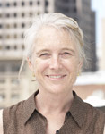
Ashley Boren is Executive Director of Sustainable Conservation, a nonprofit organization that helps California thrive by uniting people to solve the toughest challenges facing our land, air and water. Every day, they bring together business, landowners and government to steward the resources that we all depend on in ways that make economic sense. Ashley received a 2007 James Irvine Foundation Leadership Award for her “unwavering commitment to innovative, balanced problem-solving to address a variety of critical environmental problems facing California."

Ashley has directed the strategy, growth and operations of Sustainable Conservation since 1997. Prior to Sustainable Conservation, Ashley spent eight years at Smith & Hawken, a mail order and retail gardening company, where she worked in finance, new business development, inventory planning and retail merchandising. She began her career at The Nature Conservancy in program development and fundraising. In addition to her work at Sustainable Conservation, Ashley serves on the California State Board of Food and Agriculture and UC California Division of Agriculture and Natural Resources President’s Advisory Commission. Ashley previously served as Trustee and Chair of the Robert and Patricia Switzer Foundation and as a Board member and Chair of Stanford Business School’s Alumni Consulting Team. Ashley has a BA in human biology, an MA in applied economics and an MBA from Stanford University.

Renata Brillinger

Executive Director, California Climate & Agriculture Network (CalCAN)

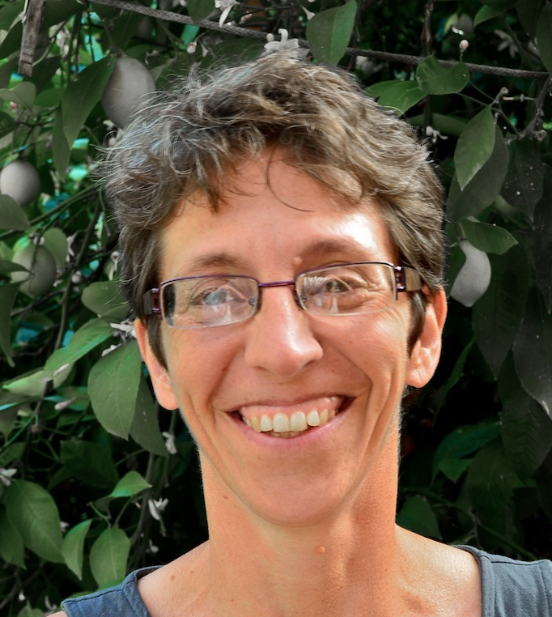
Renata Brillinger is the co-founder and Executive Director of the California Climate and Agriculture Network (CalCAN), a coalition of sustainable and organic agriculture organizations that advances policy at the nexus of climate change and agriculture. Prior to CalCAN, she was Program Director at the Climate Protection Campaign, focused on renewable energy and on agriculture. For seven years she served as the Director of Californians for GE-Free Agriculture, a coalition of sustainable agriculture and environmental organizations that provided education on genetic engineering in agriculture. She has served in numerous non-profit administrative roles since 1992. She serves on the steering committee of the California Rangeland Conservation Coalition and the steering committee of the Center for Sustainability at CalPoly University in San Luis Obispo.

Helene Dillard

Dean, College of Agricultural & Environmental Sciences, UC Davis
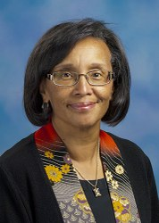
Helene R. Dillard was appointed dean of the College of Agricultural and Environmental Sciences at UC Davis in January 2014. One of her goals is to build upon the strengths of the college in research, teaching, extension and outreach, and maintain strong relationships with the broad range of stakeholders in California, nationally, and globally. Dillard has national and international leadership experience, including invited consultations, presentations, and scientific exchanges in China, Central America (Honduras, Nicaragua), South America (Argentina, Brazil, Chile), the European Union (the Netherlands, Sweden, United Kingdom), and Zimbabwe. She has worked extensively with U.S. Department of Agriculture programs, and the National Institute of Food and Agriculture (NIFA). Prior to her appointment at UC Davis, Dillard was on the faculty at Cornell University since 1984 as a plant pathology professor, carrying a 50 percent research and 50 percent extension assignment. Her research focused on the biology, ecology, and management of fungal pathogens that cause diseases in vegetable crops. Her interests include sustainable disease management strategies, integrated pest management, epidemiology and host/pathogen/environment interactions. Dillard served as chair of the Department of Plant Pathology in Geneva, N.Y. (1997–2001), associate director of Cornell Cooperative Extension (2001–2002), and director of Cornell Cooperative Extension (2002–January 2014). She also served simultaneously as associate dean in two colleges, the College of Agriculture and Life Sciences (CALS) and the College of Human Ecology (2002–January 2014).
Dillard was recognized for her contributions in plant pathology by the American Phytopathological Society (APS), receiving the Excellence in Extension Award in 1992 and being named an APS fellow in 2006. She received the New York Farmers Medal and the Outstanding Faculty Award from CALS in 2013. Helene Dillard was born and raised in San Francisco, California. She completed her B.S. degree in biology of natural resources at UC Berkeley, an M.S. degree in soil science at UC Davis, and a Ph.D. degree in plant pathology at UC Davis.
Michael Dimock

President, Roots of Change

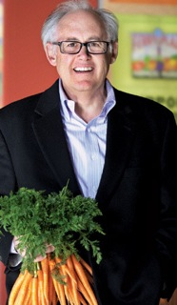
Michael R. Dimock, President of Roots of Change (ROC), is a national food movement organizer and thought leader on sustainable food and farming systems. ROC is a “think tank, do tank” delivering road maps to victory for the food movement. Michael has focused on agriculture and food since 1989. He was a marketing executive in Europe for agribusiness, farmed organically for three years in Sonoma County, and in 1992 founded Ag Innovations Network, where he began his work on consensus building and strategic planning to create healthier food and agriculture. From 2002 to 2007, he was Chairman of Slow Food USA. Author, Katrina Fried, and Photographer, Paul Mobley, feature Michael in their latest book, Everyday Heroes: 50 Americans Changing The World, published in October 2012. Michael received a BA in History with Honors at UCLA in 1983 and a Masters in International Affairs at Columbia University in 1988.

John Foraker

Chief Executive Officer, Annie’s Inc.

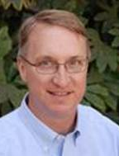
John M. Foraker has been the Chief Executive Officer and a member of the Board of Directors of Annie’s, Inc. since 2004. For over eighteen years, Mr. Foraker has held various management positions with members of our corporate family. From 1994 until 1998, Mr. Foraker served as President of Napa Valley Kitchens, Inc. and from 1998 until 2004, he served as Chief Executive Officer and a member of the board of directors of Homegrown Natural Foods, Inc. Mr. Foraker holds a BS from the University of California, Davis and an MBA from the University of California, Berkeley.

Harold Goldstein

Founder and Executive Director, Public Health Advocates

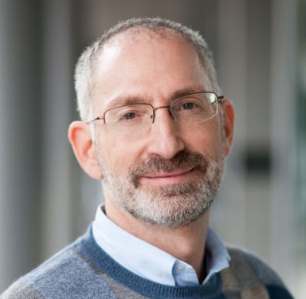
Harold Goldstein, DrPH, is the founder and executive director of Public Health Advocates, formerly known as the California Center for Public Health Advocacy. Established in 1999, Public Health Advocates helps neighborhoods and schools become places that nurture health for everyone. For more than 15 years, they have been at the forefront of solving the obesity and diabetes epidemics by working closely with partners at the state and local levels to establish groundbreaking programs and policies to build healthier communities and end health disparities. The work of PH Advocates spans almost 200 cities where local nutrition and physical activity policies have taken root. They have led successful and trendsetting statewide campaigns to remove soda and junk food from schools; acquire funding for physical education at schools; establish the nation’s first state menu-labeling law and define access to safe drinking water as a basic human right. Harold holds a bachelor’s degree in physiology from UC Berkeley, and master’s and doctorate degrees in public health from UCLA.

Glenda Humiston
Vice President, Agriculture and Natural Resources

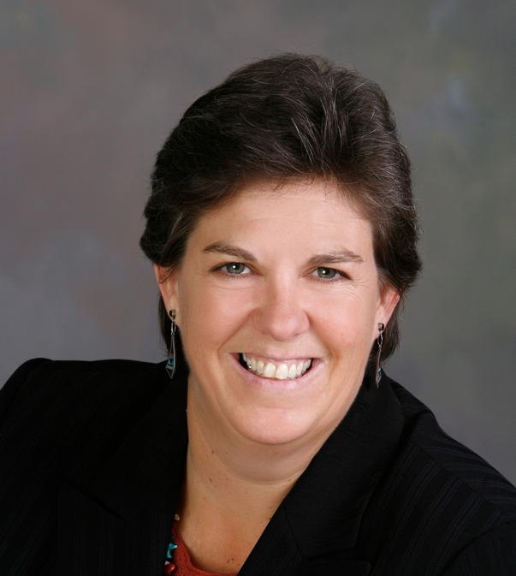
Dr. Glenda Humiston was appointed vice president of UC Agriculture and Natural Resources Aug. 3, 2015. Dr. Humiston was born in California and raised on a cattle ranch in Colorado, where she was a member of 4-H. She came to UC ANR with more than 25 years of experience working on public policy development and program implementation supporting sustainability. She served as a Peace Corps volunteer in Tunisia, as executive director of a nonprofit organization advocating farmland preservation and value-added agriculture development, and several years as a consultant on environmental and agricultural issues throughout the West. She served President Clinton as deputy undersecretary for natural resources and environment at USDA from 1998 to 2001. She managed the Sustainable Development Institute at the 2002 World Summit for Sustainable Development in South Africa and the 2006 World Water Forum in Mexico City. In 2009, Dr. Humiston was appointed by President Obama to serve as the California State Director at the U.S. Department of Agriculture (USDA), Rural Development. Dr. Humiston produced a widely acclaimed guidebook on “Access to Capital” and has led efforts to bring rural issues to the forefront of the state’s Economic Summit and policymakers throughout California. Dr. Humiston earned her Ph.D. from UC Berkeley in Environmental Science, Policy and Management in 2009 with research focused on U.S. Farm Bill policy. She has a master’s degree in international agricultural development from UC Davis and a bachelor’s degree in animal science from Colorado State University.

Carl Johnson
Chairman of the Board, Nautilus, Inc.

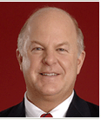
Carl Johnson recently completed a four-year run as Executive Vice President and Chief Growth Officer of Big Heart Pet Brands (sold to JM Smucker Company in March 2015) and its predecessor company, Del Monte Foods (sold to Del Monte Pacific in February 2014). At Big Heart Pet, he had responsibility for line management of the company’s widely distributed brands; Strategy; Innovation; Consumer and Customer Insights; Marketing and Creative Services; Corporate Communications; Government Relations and the company’s Canadian subsidiary. Carl is a former Senior Vice President & Chief Strategy Officer for Campbell Soup Company, where he led corporate strategy, global research & development/quality, corporate marketing services, corporate licensing and e-business. Prior to Campbell, he ran three successively larger multi-billion dollar divisions at Kraft Foods. Before Kraft, he led the Consumer Goods consulting practice at Marketing Corporation of America. Earlier, he held senior management positions at Polaroid and Colgate-Palmolive. Since 2011, Carl has been Chairman of the Board (non-executive) of Nautilus, a leading fitness company and also a director of Avedro, a pioneer in advanced refractory eye surgery. He is a Trustee of the Adelphic Educational Fund, Wesleyan University. He is also a member of the Steering Committee of the Kilts Center for Marketing at the University of Chicago Graduate School of Business.

Barry Kriebel

President, Sun-Maid Growers of California

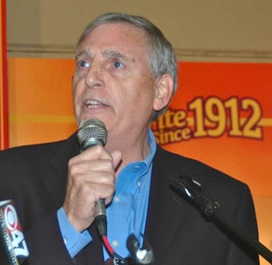
Barry Kriebel has been President of Sun-Maid Growers of California, Inc. since 1986. Mr. Kriebel served as Vice President and General Counsel of Sun-Maid Growers of California, Inc. from 1980 to 1985. He was Partner in Blumberg, Sherr & Kerkorian, Fresno, CA until 1980. He was General Counsel of Sun-Maid Growers and its Affiliates until 1976. He has a Bachelor’s degree in economics from Stanford University in 1972 and a law degree from Georgetown University in 1975.

Russ Lester

Co-Owner, Dixon Ridge Farms

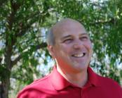
Russ Lester is co-owner of Dixon Ridge Farms and a fourth generation California farmer. Russ began farming organically in 1989 and has helped shape many organic farming concepts and practices for orchards. An advocate for farmland protection, Russ serves on the Board of Directors for Solano Land Trust and the Solano County Agricultural Advisory Board. He has been a featured speaker at national conferences on energy, farmland protection, and organic agriculture. In addition, Russ is past president of the Winters Joint Unified School District. He attended the University of California at Davis and is a graduate of the California Agricultural Leadership Program. Dixon Ridge Farms recently meet their goal of producing all of their electricity needs using renewable energy. As a consequence, they are both GHG and carbon negative.
Joann Lo

Co-Director, Food Chain Workers Alliance
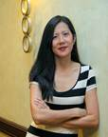
Joann Lo is the Co-Director of the Food Chain Workers Alliance (FCWA), a national coalition of workers organizations joined together to improve wages and working conditions and to work towards a more sustainable food system. She graduated from Yale University with a degree in Environmental Biology and has organized with both unions and a worker center. In 2000 Joann was one of two staff who started the Garment Worker Center, and she organized with garment workers in Los Angeles who led a successful campaign against retailer Forever 21, memorialized in the Emmy-winning documentary “Made in L.A.” In 2005 Joann joined Enlace, an alliance of worker centers and unions and a year later became Co-Director. She joined the FCWA a few months of its launch in July of 2009. Joann is the Chair of the Leadership Board of the Los Angeles Food Policy Council. She is also a member of the Board of Directors of the Center for Good Food Purchasing and the Domestic Fair Trade Association and a member of the City of Los Angeles’ Sweatfree Advisory Committee.
Marshall McKay

Chairman Emeritus, Yocha Dehe Wintun Nation
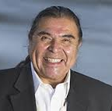
Chairman Emeritus Marshall McKay led the elected Tribal Council of the Yocha Dehe Wintun Nation. He began his career in tribal government in 1984 and in January 2012 was re-elected to his third term as Chairman. Born in Colusa, California, the Chairman grew up in Brooks near his present-day home in the Yocha Dehe tribal community. A cornerstone of his leadership is his commitment to cultural renewal and preservation, a focus he extends into education programs and sustainable land-use practices. Chairman Emeritus McKay oversaw the day-to-day operations of the tribal government, the Tribe’s Cache Creek Casino Resort and its other business endeavors. Prior to being elected Chairman, he served as Tribal Treasurer and Tribal Secretary. Chairman McKay is a board member of the UC Davis Foundation, and chairman of the board of both the Smithsonian’s National Museum of the American Indian and the Autry National Center in Los Angeles. He is a founding member and chair of the Native Arts & Cultures Foundation, and a gubernatorial appointee to the Native American Heritage Commission (NAHC) and the State Historical Preservation Commission. Chairman McKay’s mother, doctor and basket weaver Mabel McKay, was one of the NAHC’s founding commissioners. Chairman McKay is dedicated to the preservation and promotion of Native arts and culture, the affirmation of sovereign tribal governance, and the international effort to protect the rights of all indigenous people. He travels extensively to participate in conferences, summits and fundraisers that support initiatives important to the Yocha Dehe Wintun Nation. Chairman McKay and his wife, Sharon Rogers McKay, are passionate supporters and collectors of contemporary Native art. They enjoy traveling to cultural events, and sharing time with their children and grandchildren.

David M. Meddaugh
Senior Vice President, Specialty Food & Beverage Market Manager, Bank of America, Merrill Lynch
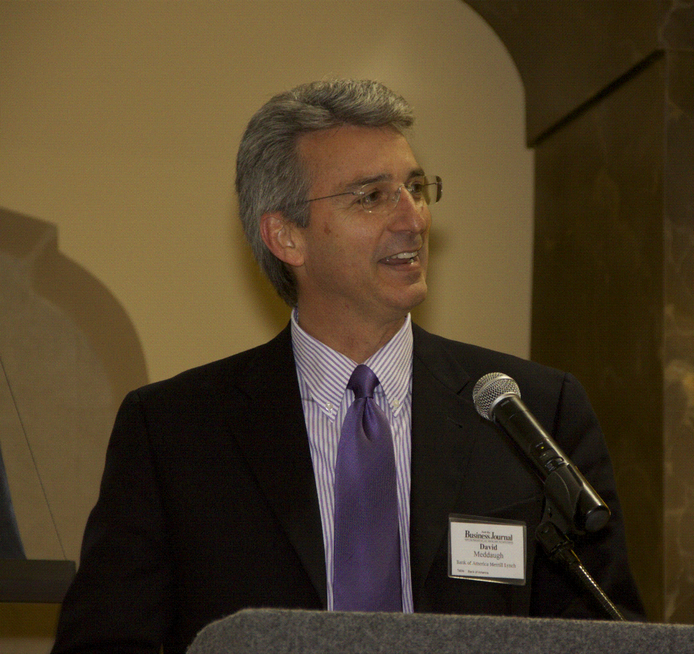
David Meddaugh and the North Coast Commercial Banking Office of Bank of America Merrill Lynch cover the Specialty Food and Beverage Industries in the North Coast area for Middle Market sized companies. The Middle Market space covers companies with annual revenues from $50 million to $2 billion. The North Coast Commercial Banking Office serves middle market companies located north of the Golden Gate Bridge to the Oregon Border. We serve the geography of Marin, Sonoma, Napa, Lake, Mendocino, Humboldt and Del Norte counties, as well as Lodi, Monterey and Paso Robles areas for companies in the Wine Industry. David Meddaugh is a 34 year Bank of America professional working in the mid-market space. He has significant experience in working with Specialty Food and Wine Industry clients. He holds a MBA graduate degree from Pacific Coast Banking School at the University of Washington, and Bachelor degrees in Finance and Economics from California State University Chico. David is also an active representative of BAML in the area of Philanthropy and Sponsorship and is a Board member of Sonoma County BEST and co-founder of the BEST Food Industry Group. David sits on the Loan Committee for California Farmlinks. He is also active with the Sonoma County Alliance. David has been a board member of United Way, and was Co-Founder of the Sonoma County Business Environmental Alliance, an organization founded to promote the use of environmental best practices to drive economic returns.
Active in his community, David has been presented with Bank of America’s prestigious CEO Eagle Award for Excellence and was Northern California’s sole recipient of the 1998 Customer Experience Leadership Award (CELA). Additionally, he received the Bank of America Spirit Award of Excellence in years 2000- 2005, 2007 & 2009, 2010. He also received the Independent Market Leader Award in 2011. He is a prior graduate of Leadership Santa Rosa Class 16. David is also a licensed investment representative with both Series 7 and Series 63 licenses. David was raised in Santa Rosa, attending local elementary and secondary schools as well as Santa Rosa Junior College. David and his wife and
Patrick Mulvaney
Chef Owner, Mulvaney’s B&L Restaurant and Culinary Specialist Catering Company
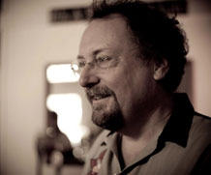
Patrick Mulvaney, of Mulvaney’s B&L Restaurant and Culinary Specialist Catering Company is a proud Sacramentan whose cooking career has spanned five time zones. His travels have taken him from a European apprenticeship through The River Café in Brooklyn, RoxSand in Phoenix to Paragary’s & The Kitchen in Sacramento. In 2001 he began Culinary Specialists, opening Mulvaney’s B&L in 2006 and adding Next Door in 2008. It is Sacramento's proximity to farmers and the abundance they produce which feeds both the creative spirits of his team and the appetites of his guests. The Building & Loan takes its name from the famous Frank Capra film because for a chef living in Sacramento it truly is a wonderful life. The B&L operates from the historic Engine Co. 3 firehouse at 1215 19th Street. Mulvaney’s B&L was selected by Open Table as one of the top 100 American Restaurants. At the same time the nationally recognized Zagat raised their food score to 29 out of 30, one of only a hand full of restaurants nationwide.

Gabriel Patterson
Graduate Student Representative, Agricultural and Environmental Chemistry Graduate Group


Gabriel (Gabe) Patterson is a graduate student in the Agricultural and Environmental Chemistry Graduate Group at UC Davis, where he is pursuing his PhD in Fiber and Polymer Science. Specifically, his projects will focus on resource recovery of agricultural residues and their biorefinement into cellulosic materials that are renewably sourced and biodegradable. Potential directions include the design and preparation of cellulose membranes for proton transfer in hydrogen fuel cells and ion transfer in batteries. Before coming to Davis, Gabe lived in Rio de Janeiro, Brazil where he worked as a rock climbing guide as well as co-founded a start-up English as a Second Language company. Shortly before embarking on his sabbatical to Brazil, Gabe lived in Panama City, Panama where he interned as a field researcher for the Smithsonian Tropical Research Institute. He holds a BA in Environmental Science Concentration in Chemistry from the Colorado College. His research undergraduate experience with the National Renewable Energy Laboratory (NREL) in 2012 has greatly influenced Gabe’s academic and professional trajectory. Gabe hopes to pay forward his education and many experiences abroad by working with international renewable energy programs upon graduation.

Amparo Perez-Lemus
AP Lemus & Associates
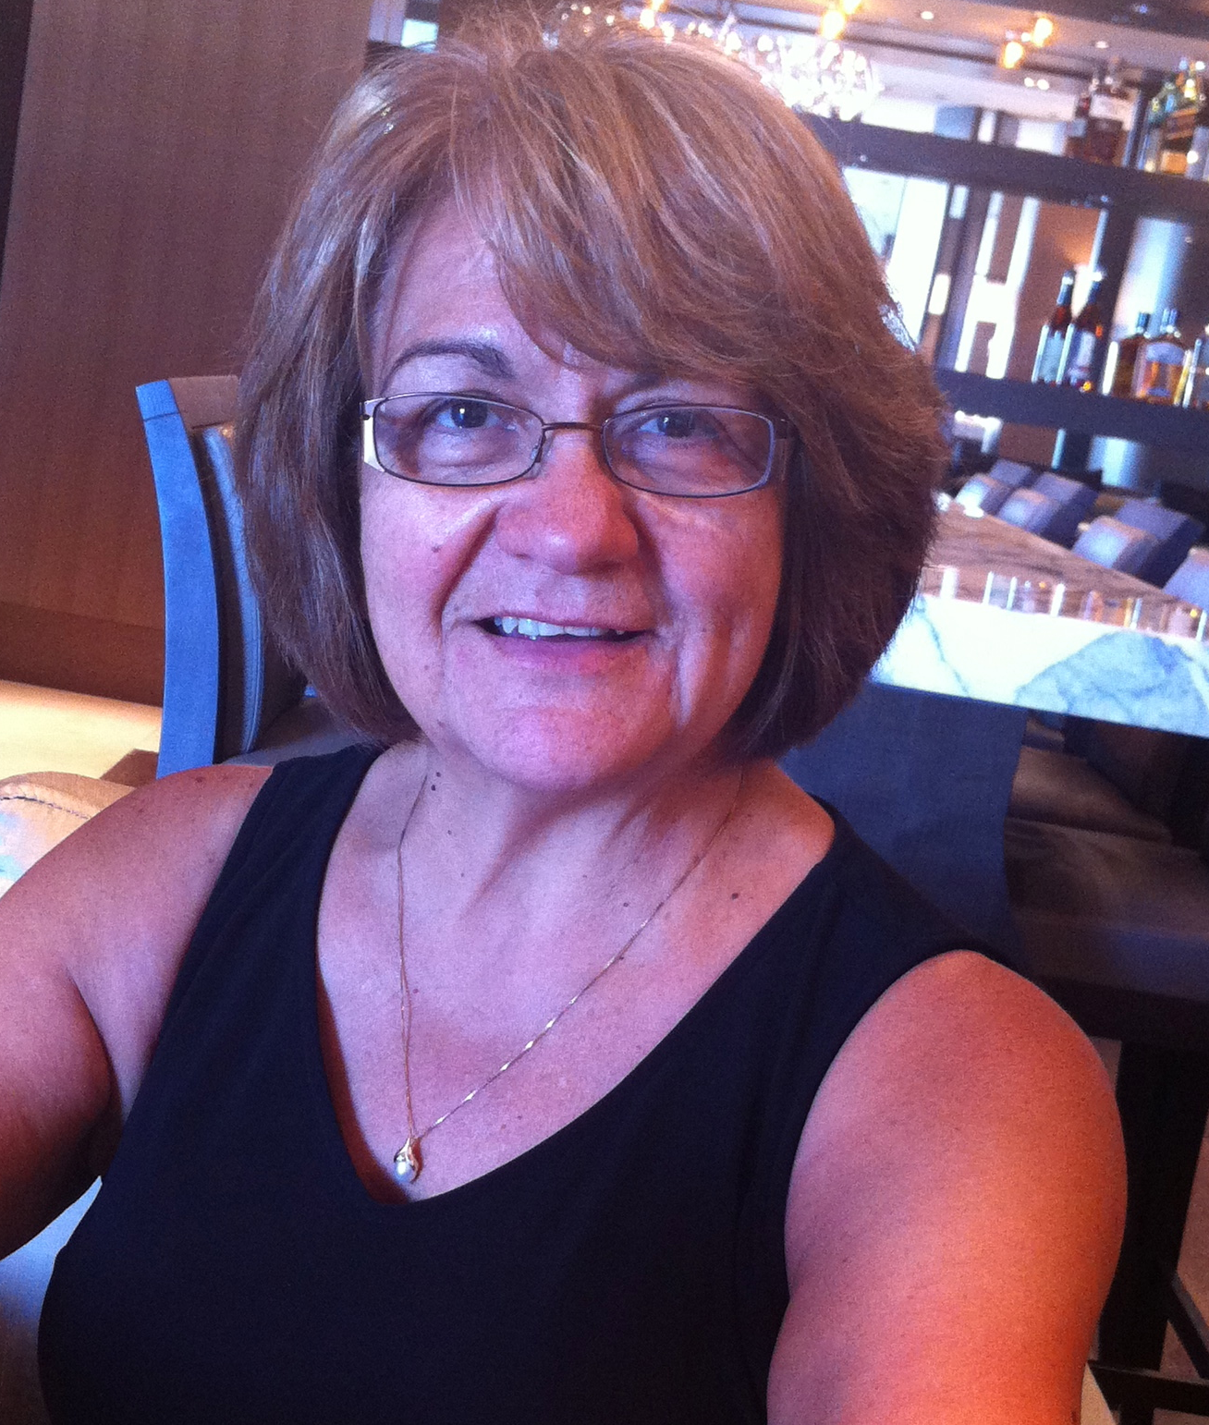
Amparo currently works at AP Lemus & Associates Marketing and Public Relations, Hispanic marketing specialists focusing on reaching the Latino community. She is also owner of Body, Soul & Wealth, helping others create true prosperity with LifeVantage. She previously was Vice President and General Manager, Adelante Media Broadcasting Company.

Karen Ross

Secretary, California Department of Food and Agriculture

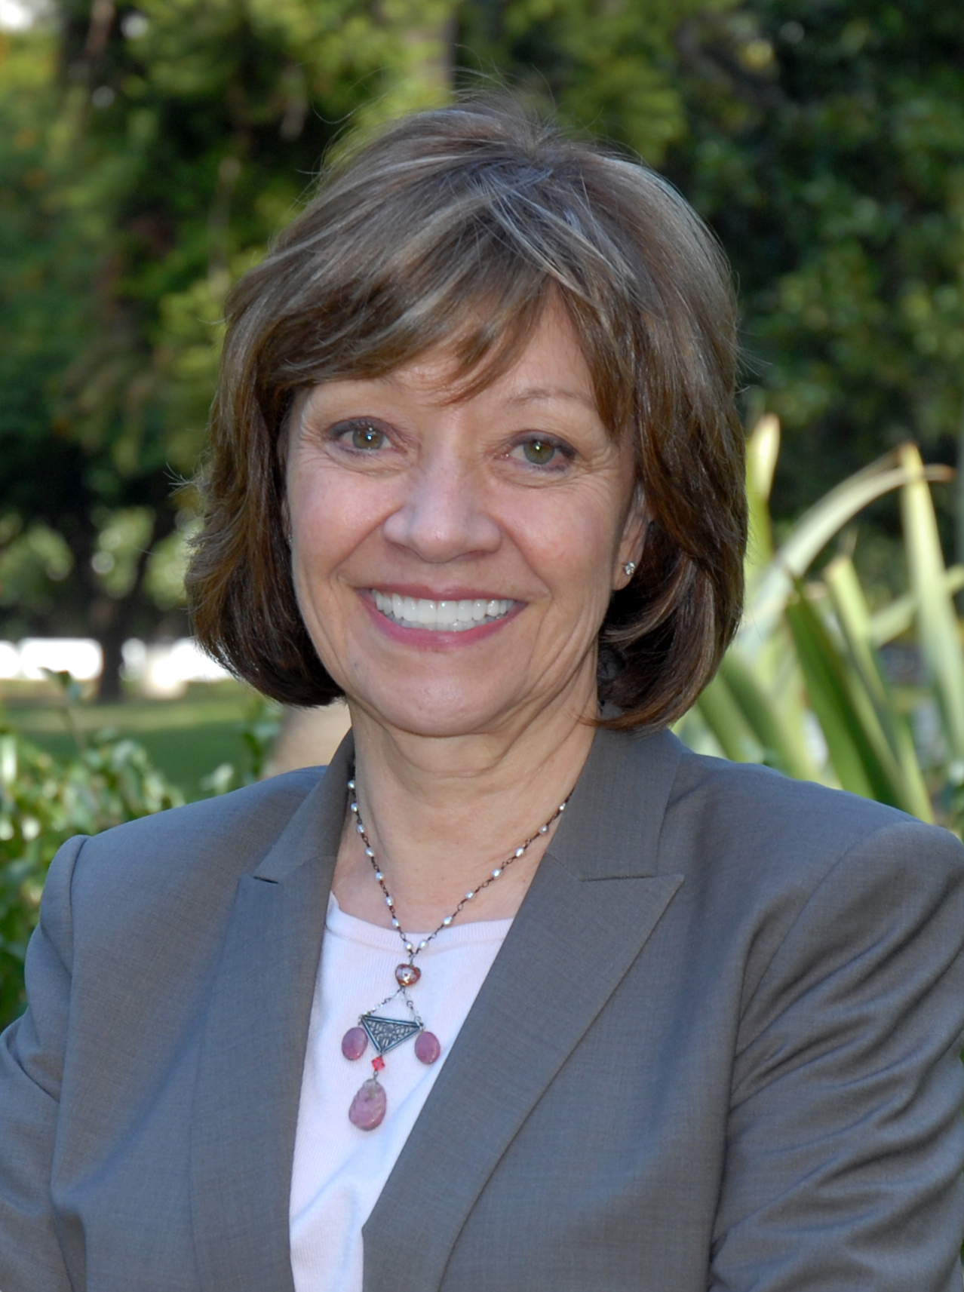
Karen Ross was appointed Secretary of the California Department of Food and Agriculture on January 12, 2011, by Governor Edmund G. Brown Jr. Secretary Ross has deep leadership experience in agricultural issues nationally, internationally, and here in California. Prior to joining CDFA, Secretary Ross was chief of staff for U.S. Agriculture Secretary Tom Vilsack, a position she accepted in 2009. Prior to that appointment, she served as President of the California Association of Winegrape Growers from 1996- 2009, and as Vice-President of the Agricultural Council of California from 1989-1996. Before moving to California, Secretary Ross served as Director of Government Relations for the Nebraska Rural Electric Association and as Field Representative for U.S. Senator Edward Zorinsky. Secretary Ross is passionate about fostering the reconnection of consumers to the land and the people who produce their food, and to improving the access of all California citizens to healthy, nutritious California-grown agricultural products, celebrated for their diversity and abundance in serving local, national and global markets.

During Secretary Ross' tenure, the Department has focused on core functions to protect and promote California agriculture in a time of significant budget reductions, and it has emphasized change-management to position the agency to more effectively and efficiently serve its stakeholders in meeting the challenges of the 21st Century.

Secretary Ross has strengthened partnerships across government, academia and the non- profit sector in the drive to maintain and improve environmental stewardship and to develop adaptation strategies for the specific impacts of climate change. She has initiated programs to provide greater opportunities for farmers and ranchers to engage in sustainable environmental stewardship practices through water conservation, energy efficiency, nutrient management and ecosystem services.

Secretary Ross grew up as a 4-H kid on a farm in western Nebraska. She and her husband, Barry, own 800 acres of the family farm where her younger brother, a fourth-generation farmer, grows dryland wheat, feed grains and cattle. The Secretary has a Bachelor of Arts degree from the University of Nebraska-Lincoln and is a graduate of the Nebraska Ag Leadership Program. She has served on numerous boards and committees in California agriculture and with various academic institutions.

D’Artagnan Scorza
Founder and Executive Director, Social Justice Learning Institute

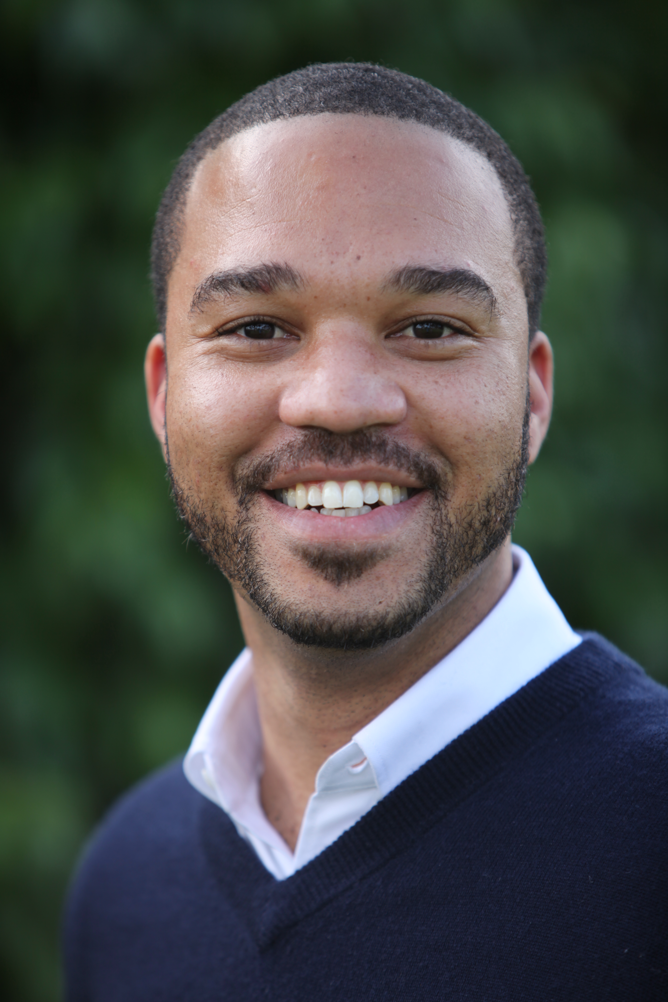
Dr. D’Artagnan Scorza is the Founder and Executive Director of the Social Justice Learning Institute (SJLI) in Inglewood. Dr. Scorza is a graduate of Morningside High School, a US Navy Iraq-War Veteran and native son of Inglewood. He has a Ph.D. in Education from UCLA, a B.S. in Liberal Studies from National University and a B.A. in the Study of Religion from UCLA. Dr. Scorza served as a UC Regent from 2007-2009 where he passed policies that helped expand access to education for African-American and Latino youth, established veteran’s service centers and prioritized $160 million for student services. Dr. Scorza is community organizer with extensive program development and policy experience and he’s helped passed green school policies and statewide policies democratizing food access. He was 2010 Education Pioneers Fellow and a 2013-2014 Business Alliance for Local Living Economies (BALLE) Fellow where he expanded his expertise in socially responsible economic development. He’s currently engaged in grassroots policy efforts affecting boys and men of color, health equity and local economic development. At SJLI, Dr. Scorza leads a team that works to close disparities in education, expand business opportunities, improve health in the built environment and help youth of color go to college. Dr. Scorza chaired the Measure GG campaign for IUSD, powered by concerned local residents, to secure $90 million in school improvement bonds to update facilities and expand access to a safe, healthy and quality education. He serves on the Los Angeles and California Food Policy Councils and was elected to the Inglewood Unified School District, Board of Education.

Howard-Yana Shapiro
Chief Agricultural Officer, The First Mars Advanced Research Institute Fellow, Mars, Inc.
Senior Fellow, Department of Plant Sciences, Plant Reproductive Biology, College of Agricultural and Environmental Sciences, UC Davis
Distinguished Fellow, World Agroforestry Centre, Nairobi, Kenya

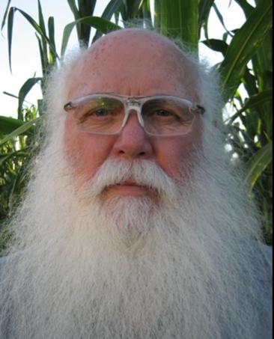
Howard has been involved with sustainable agricultural and agroforestry systems, pattern recognition, plant breeding, molecular biology and genetics for over 40 years releasing hundreds of cultivars into the public domain. He has worked with indigenous communities, NGO’s, governmental agencies and the private sector around the world. A former university professor for 15 years, Fulbright Scholar, Ford Foundation Fellow, in 2007 Howard was made a Fellow of the World Agroforestry Centre and authored the IAASTD chapter on Biotechnology and Biodiversity. He was a founding member of the Keystone Roundtable on Sustainable Agriculture, co-chair of the 1st and 2nd World Congress of Agroforestry and is Chairperson of the External Advisory Board of the Agriculture Sustainability Institute at UC Davis. In 2009 he was named recipient of The Award of Distinction from The College of agriculture and Environmental Sciences, UC Davis. He led the global effort sequencing, assembling and annotating the Theobroma cacao genome and is part of the leadership team for the Arachis genome global effort. In 2010 he was named a Senior Fellow, Plant Sciences, the University of California, Davis. September 2011, he announced the formation of the African Orphan Crops Consortium, set up to sequence, assemble and annotate 101 of the key African food crops in order to breed more nutritious plants. He as well set up the African Plant Breeding Academy with UC Davis at the World Agroforestry Centre in Nairobi which opened the 3rd of December 2013. He has served on both for profit and NGO boards.
He collects and restores classic American, modern Japanese and Italian motorcycles. He recently became a member of the 200 Mile Per Hour Club on an unrestricted 1999 Suzuki Hayabusa, averaging 201.386 MPH.

Rachel Surls

Sustainable Food Systems Advisor for UC Cooperative Extension, Los Angeles County

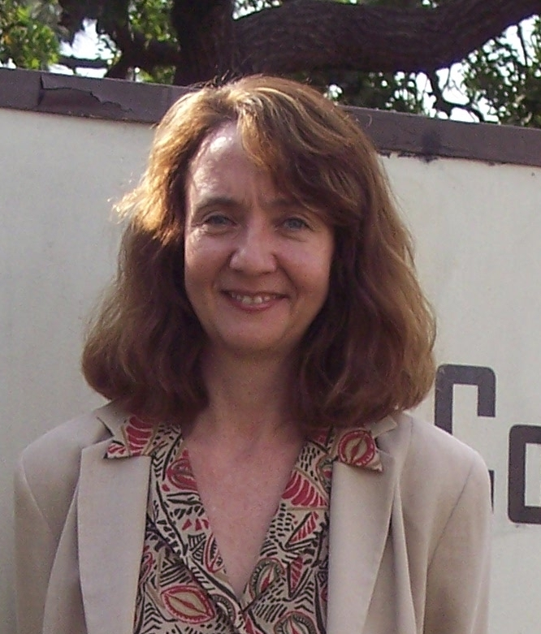
Rachel Surls is the Sustainable Food Systems Advisor for University of California Cooperative Extension in Los Angeles County. Cooperative Extension is part of the University of California’s Division of Agriculture and Natural Resources. As part of her role with UC ANR, she recently led a team that studied the emerging urban agriculture movement in California, assessing the needs of this audience, creating educational resources, and developing best practice recommendations for urban agriculture policy at the municipal level. She is currently a member of the Los Angeles Food Policy Council’s Leadership Board, and through the Council has been actively engaged in working with the City of Los Angeles to formulate urban agriculture policy. Rachel is a long-time UC ANR staff member and has served in several capacities. She was County Director for Cooperative Extension in Los Angeles from 1997-2011, and Urban Horticulture Advisor in Los Angeles County from 1994-1997. She has been active in supporting school and community gardening in the Los Angeles area since joining Cooperative Extension as a Program Representative with Cooperative Extension’s Urban Garden Program in 1988. She earned her BS in agronomy at Virginia Tech, her MS in Agricultural Sciences at Cal Poly, Pomona, and a Ph.D. in Education from Claremont Graduate University. Rachel is a former Peace Corps Volunteer and parent of two young adults. She is the co-author of “From Cows to Concrete: The Rise and Fall of Farming in Los Angeles” published in 2016 by Angel City Press.

Kat Taylor

Founder, TomKat Ranch Educational Foundation; Co-CEO, Beneficial State Bank; San Francisco

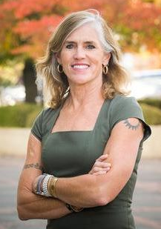
Kat Taylor is intent on changing the food and banking systems for good through business models and philanthropy. She believes that agriculture represents the dominant way we tend the planet, for better or for worse. To find and de-risk animal agriculture management practices that optimize for greatest societal value, Kat founded TomKat Ranch Educational Foundation on her family's cattle ranch. With science partners Point Blue on site and broader science-based collaborative experimentation, TKREF hosts a learning lab for strategies to re-sequester carbon into soils, enhance water quality and retention, and restore biodiversity, all while producing a healthy food product. TomKat Charitable Trust, the family charitable vehicle, funds a robust ecosystem for food system change to complement the working ranch activities. Among the Trust's priorities are big buyer strategies to shift supply chains beneficially (like California Food for California Kids), empowerment of eaters from all settings (from basic agro-ecology research to protection of transparency in food markets), and food movement-building. Kat also believes that Banking is our original and most powerful form of crowdfunding so it's important to get it right. To gain insights for aligning banking with benefit to all and harm to none, she and her husband started Beneficial State Bank in 2007. Beneficial State Bank is owned in the public interest, reinvesting profits into the low-resourced communities it serves and the earth upon which we all depend. BSB adheres to a lending practice that preponderently supports (with 75% or more of the loan dollars) a just and renewable economy and eschews contra-mission activities. BSB also broadcasts to its stakeholders all financial and non-financial performance results, from BCorp and JUST assessment ratings to green house gas, landfill and water footprints. Kat serves as Co-CEO of the bank and Co-Chair of the bank and bank holding companies. Kat also supports all efforts to avert climate disaster and restore broad-based prosperity. Kat graduated from Harvard College in 1980 and earned a JD/MBA from Stanford University in 1986. Her husband and four grown children are all also pursuing their own wild and precious lives and love gathering over food, playing sports and communing with the great outdoors.

Thomas Turini

Vegetable Crops Farm Advisor, UC Cooperative Extension, Fresno County

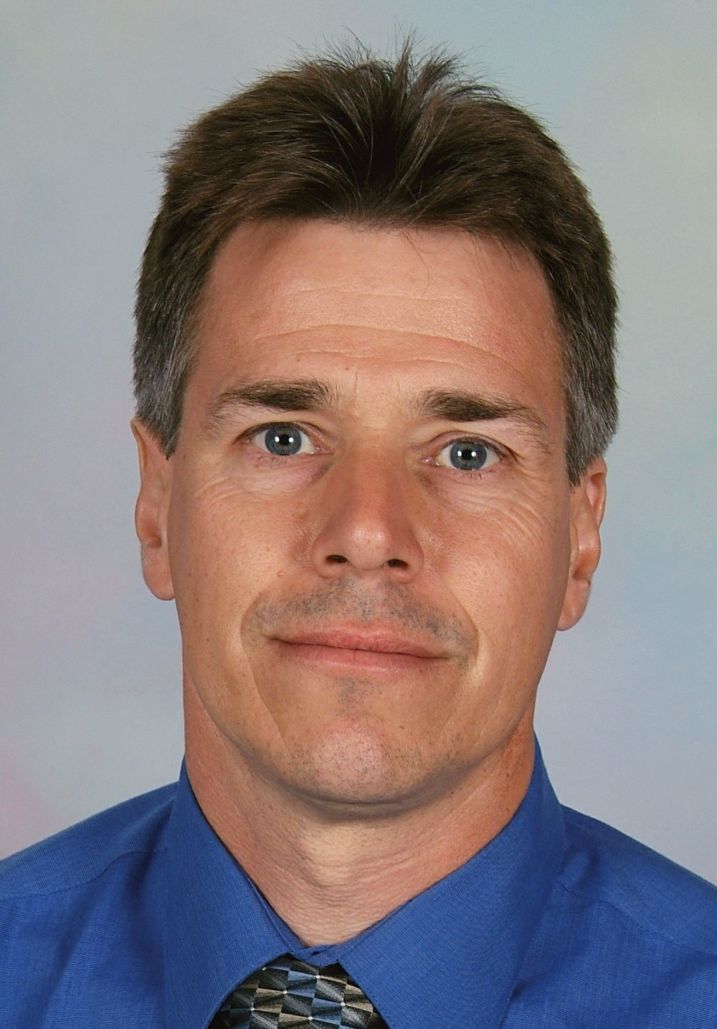
Tom Turini is the vegetable crops Farm Advisor for Fresno County where he has served since 2007. His research and extension program addresses management of tomatoes, garlic, onions, melons and lettuce in large-scale agricultural operations in the county. A critical component of his program is diagnosis of production issues, which provides a service to clientele and helps to direct his program toward relevant issues. His research includes management of water and salinity in high yielding drip-irrigated processing tomatoes, evaluation of fate of herbicides in processing tomatoes under current production methods, and alternative nutritional regimes for processing tomato. His current work in the area of pest management includes the study of site-specific methods of control of white rot of garlic and onion, Fusarium Wilt of lettuce management, powdery mildew of melon fungicide resistance management and means of controlling insect pests of tomato with lower risk materials. He is serving as UC liaison for the California Garlic and Onion Research Advisory Board. Prior to taking his current position, he served as the Imperial County Plant Pathology Advisor since 1999. He received both a BS and MS from California State University, Fresno in Plant Science.

Paul Wenger
President, California Farm Bureau Federation; Farmer
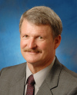
Paul Wenger is President of the California Farm Bureau Federation. Wenger, who farms in Modesto, became a statewide officer in 1997 when he was elected second vice president, and became first vice president in 2005. A third-generation farmer, Wenger farms almonds and walnuts on the family farm, which includes property purchased by his grandfather in 1910. His farming operations also include sharecropping, custom farm work and walnut hulling. He has expanded his operation to include processing and marketing of almonds and walnuts through his Wood Colony Nut Co., to provide an opportunity for the fourth generation of the family to vertically integrate into the family farming operation. Wenger has been active in community affairs, serving on the Salida Volunteer Fire Department, the Hart-Ransom School Board of Trustees, and the Stanislaus Land Trust and Agricultural Pavilion boards.

