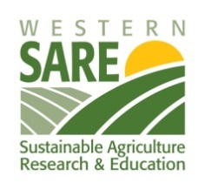

Western SARE Professional Development Program in California invites proposals for
Education Implementation Mini-Grants
WSARE California invites proposals for small grants ($5,000-$10,000 each) to assist agricultural professionals (UC ANR, NRCS, RCD and others) in providing opportunities for educational and professional development to other California-based agricultural professionals. The program will award 2 or 3 small grants geared to professional development activities targeted primarily to agricultural professionals such as extension staff, non-profit, state and federal agency staff, PCAs/CCAs, etc. Farmers and ranchers may be included but should NOT be the primary audience. The goal is to increase the capacity of agriculture professionals to apply the principles of sustainable agriculture while working with their clientele (farmers, ranchers, consumers, youth, businesses, government, or communities).

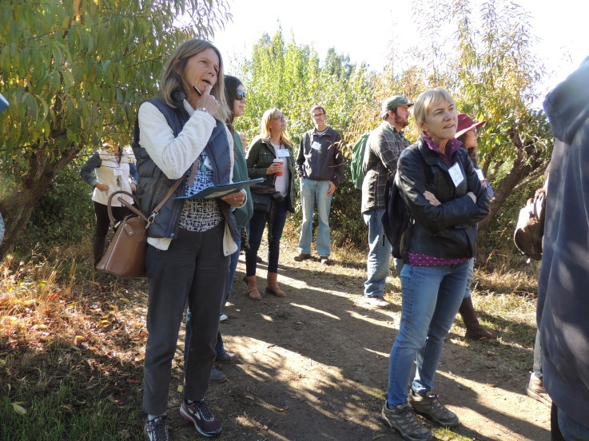
High-priority topics include:
• Ag resiliency and climate change
• Fire: wild and prescribed
• Soil health in crop and rangeland
• Biodiversity, habitat and integrated pest management
• Water use efficiency
• Nutrient management practices to minimize environmental impairments
• Alternative marketing approaches
• Community-based food systems
• Planning for succession and/or post-disaster continuity

All proposals will be reviewed by a panel of stakeholder reviewers.
Please complete the application starting on the following page
Email your completed application to: paleff@ucdavis.edu
Important: Please put “SARE for CA Mini-grant” in the subject line.
Final date for acceptance of WSARE California Mini-Grant Proposals is February 25, 2019, by 5 pm.
Who can apply:
Any California-based professional whose position involves extension of agricultural production, conservation or marketing information to agricultural producers at all scales.
All applicants will be notified of funding decision by April 30, 2019.
For more information on the grant proposal process, please contact Penny Leff, UC SAREP, paleff@ucdavis.edu or 530-752-5208.
For more information about Western SARE, please see www.westernsare.org or contact Sonja Brodt, sbbrodt@ucdavis.edu or Jeff Stackhouse, jwstackhouse@ucanr.edu.

Western SARE Professional Development Program for California
MINI-GRANT APPLICATION
Due Monday February 25, 2019 (by 5 pm)
1. APPLICANT INFORMATION
a. Applicant Name:
b. Address:
Street line 1:
Street line 2:
City:
County:
State:
Zip/Postal Code
Email Address:
…………………………………………………………………………………………………………………………………………………………
Phone No.:
c. Organization:
Department or unit: | County or region:
2. Have you previously received a WSARE California Mini-Grant?
YES [ ] NO [ ]
(If yes, attach a final report to your emailed application if you have not already submitted one.)
4. Proposed Date Range for Use of Funds. Projects must be completed between April 15, 2019 and February 28, 2020:

5. Project Title:

6. Issues and Areas (counties, regions) Addressed by Project:

7. List of partners and/or collaborators (please provide name and title or affiliation, and role on the project):

8. PROJECT DESCRIPTION
- Two to three sentence summary of project objective and methods (or activities).

- Who is the target audience? Specifically identify the group or groups that will be targeted for participation in your project.

- Describe briefly what you’re going to do, such as hold an educational workshop, produce educational material, etc. Provide relevant details such as location, proposed agenda topics, and estimated number of attendees or target audience.

- How will you promote your events or products to ensure they reach your target audiences?

- What changes in awareness, knowledge or attitudes are expected to occur as a result of the target audience participating in the project? (Be specific)

- What changes in decision-making, intentions or actions do you hope will take place among the target audience as a result of your project? (Be specific)

- What is the intended benefit from these changes (e.g. improved stewardship, economics, market access)?

- Evaluation plan – How will you determine if your educational outcomes have been achieved? (Describe the methods). Please note that, in addition to your own internal evaluation, each grantee will be required to complete a project evaluation form that will be provided after the grant is awarded.

8. Proposed Budget: Maximum amount: $10,000. Projects in the range of $5,000-7,000 more likely to be funded.
(note: final grantee budgets must follow University of California and SARE requirements)
- Facility rental $
- Printing/media $
- Supplies & Exp. $
- Domestic Travel $
- Personnel
  - Salary $
  - Benefits $
- Honoraria/stipends $
- Other $

Total $

BUDGET NARRATIVE
Budget Narrative: Explain the expenses listed. Eligible expenses include reasonable speaker and project travel expenses, salaries and benefits, notebooks, publications used at meeting or event, plot or project inputs (like seed or fertilizer), postage, promotional expenses, photocopies, laboratory analysis expense and equipment rental.
Ineligible expenses include equipment and food, including food service items such as plates and cups. The exceptions to this "food rule" are if participants have to travel more than 50 miles to an event or if the continuity of the event will be broken up by meals being served off-site.

